 | EU Declaration of Conformity  Servidrone1000C5 | Version: 02  Date of application:  19/02/2026

The undersigned François HOUSSARD declares that the UAS Servidrone1000C5 is class C5 and has a guaranteed sound power level of 93 dB

Class | Manufacturer | Type | Model
C5 | François HOUSSARD (Servidrone31) | Multirotor | Servidrone1000C5

François HOUSSARD used his internal manufacturing controls (Delegated Regulation (EU) 2019/945 PART 7 module A of the evaluation) to establish the compliance of the Servidrone900 multirotor drone.
François HOUSSARD declares under his responsibility as designer and manufacturer of the multirotor that it complies with the essential elements of the standards and normative documents established by Delegated Regulation (EU) 2019/945 of 12 March 2019 on unmanned aircraft systems. The harmonised standards below have been applied.

UAS | prEN 4709-006:2023, prEN 4709-007:2023
Radio  Futaba 14SG | EN 300 328 V2.2.2, EN 300 440 V2.2.1, EN 303 413 V1.2.1
Safety | EN 62368-1:2014+A11:2017
Health | EN IEC 62311:2020, EN 62479:2010
EMC | EN 55032:2015+A11:2020, EN 55035:2017+A11:2020, EN 301 489-1 V2.2.3,  EN 301 489-3 V2.1.1, EN 301 489-17 V3.2.4, EN 301 489-19 V2.1.1, EN IEC 61000-3-2:2019, EN 61000-3-3:2013+A1:2019
RoHS | 2011/65/EU (EU)2015/863
UAS | 2012/19/EU
RoHS | 2006/1907/EC
WEEE | prEN 4709-006:2023, prEN 4709-007:2023, peEN 4709-001 :2019
REACH | EN 300 328 V2.2.2, EN 300 440 V2.2.1, EN 303 413 V1.2.1
Operational Safety Objectives | OSO#03, OSO#06, OSO#20, OSO#23

Scope of the declaration :
Delegated Regulation (EU) 2019/945

Servidrone1000C5
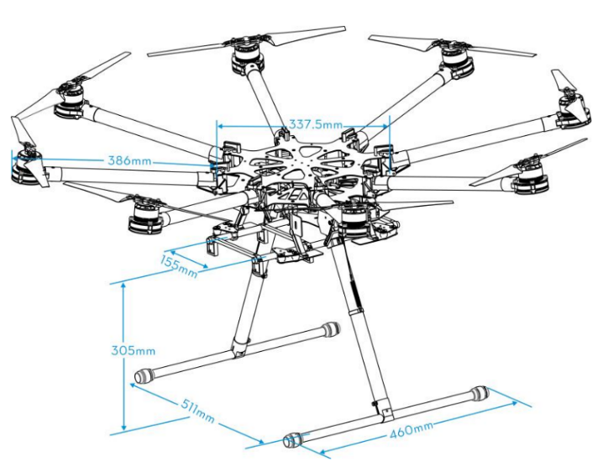

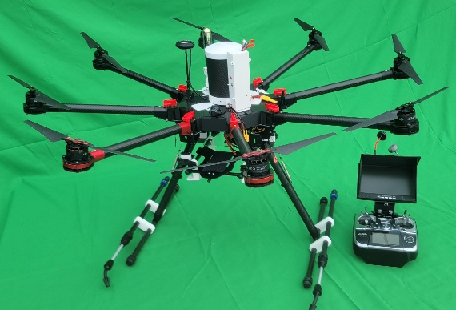

During flight, the color screen provide the remote pilot with clear and concise information on the height of the UA above the surface or take-off point;
There is a special description of the means to terminate the flight
MTOM is 11kg so less than 25 kg, including payload and have a maximum characteristic dimension of less than 3 m, the Servidrone 1000 is 1m length;
Altitude maximum attainable height above the take-off point limited to 120 m
Servidrone 1000 is safely controllable with regard to stability, manoeuvrability and the command and control link performance, by a remote pilot with adequate competency as defined in Implementing Regulation (EU) 2019/947 and following the manufacturer’s instructions, as necessary under all anticipated operating conditions including following the failure of one or, if appropriate, more systems;
Servidrone 1000 have a tensile length of the tether that is less than 50 m and a mechanical strength of no less than: 4 times the force exerted by the combination of the maximum static thrust and the aerodynamic force of the maximum allowed wind speed in flight;
Servidrone 1000 is exclusively powered by electricity;
Color screen provide the remote pilot with clear warning when the battery of the UA or its command unit reaches a low level such that the remote pilot has sufficient time to safely land the UA;
It’s equipped with lights for the purpose of controllability of the UA and with at least one green flashing light.

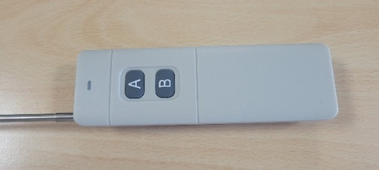
Parachute system with remote and motor cut off circuit :
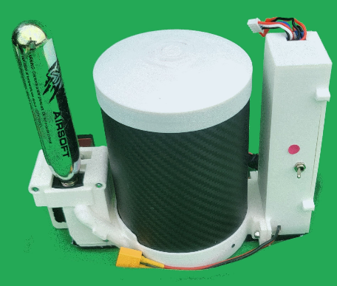
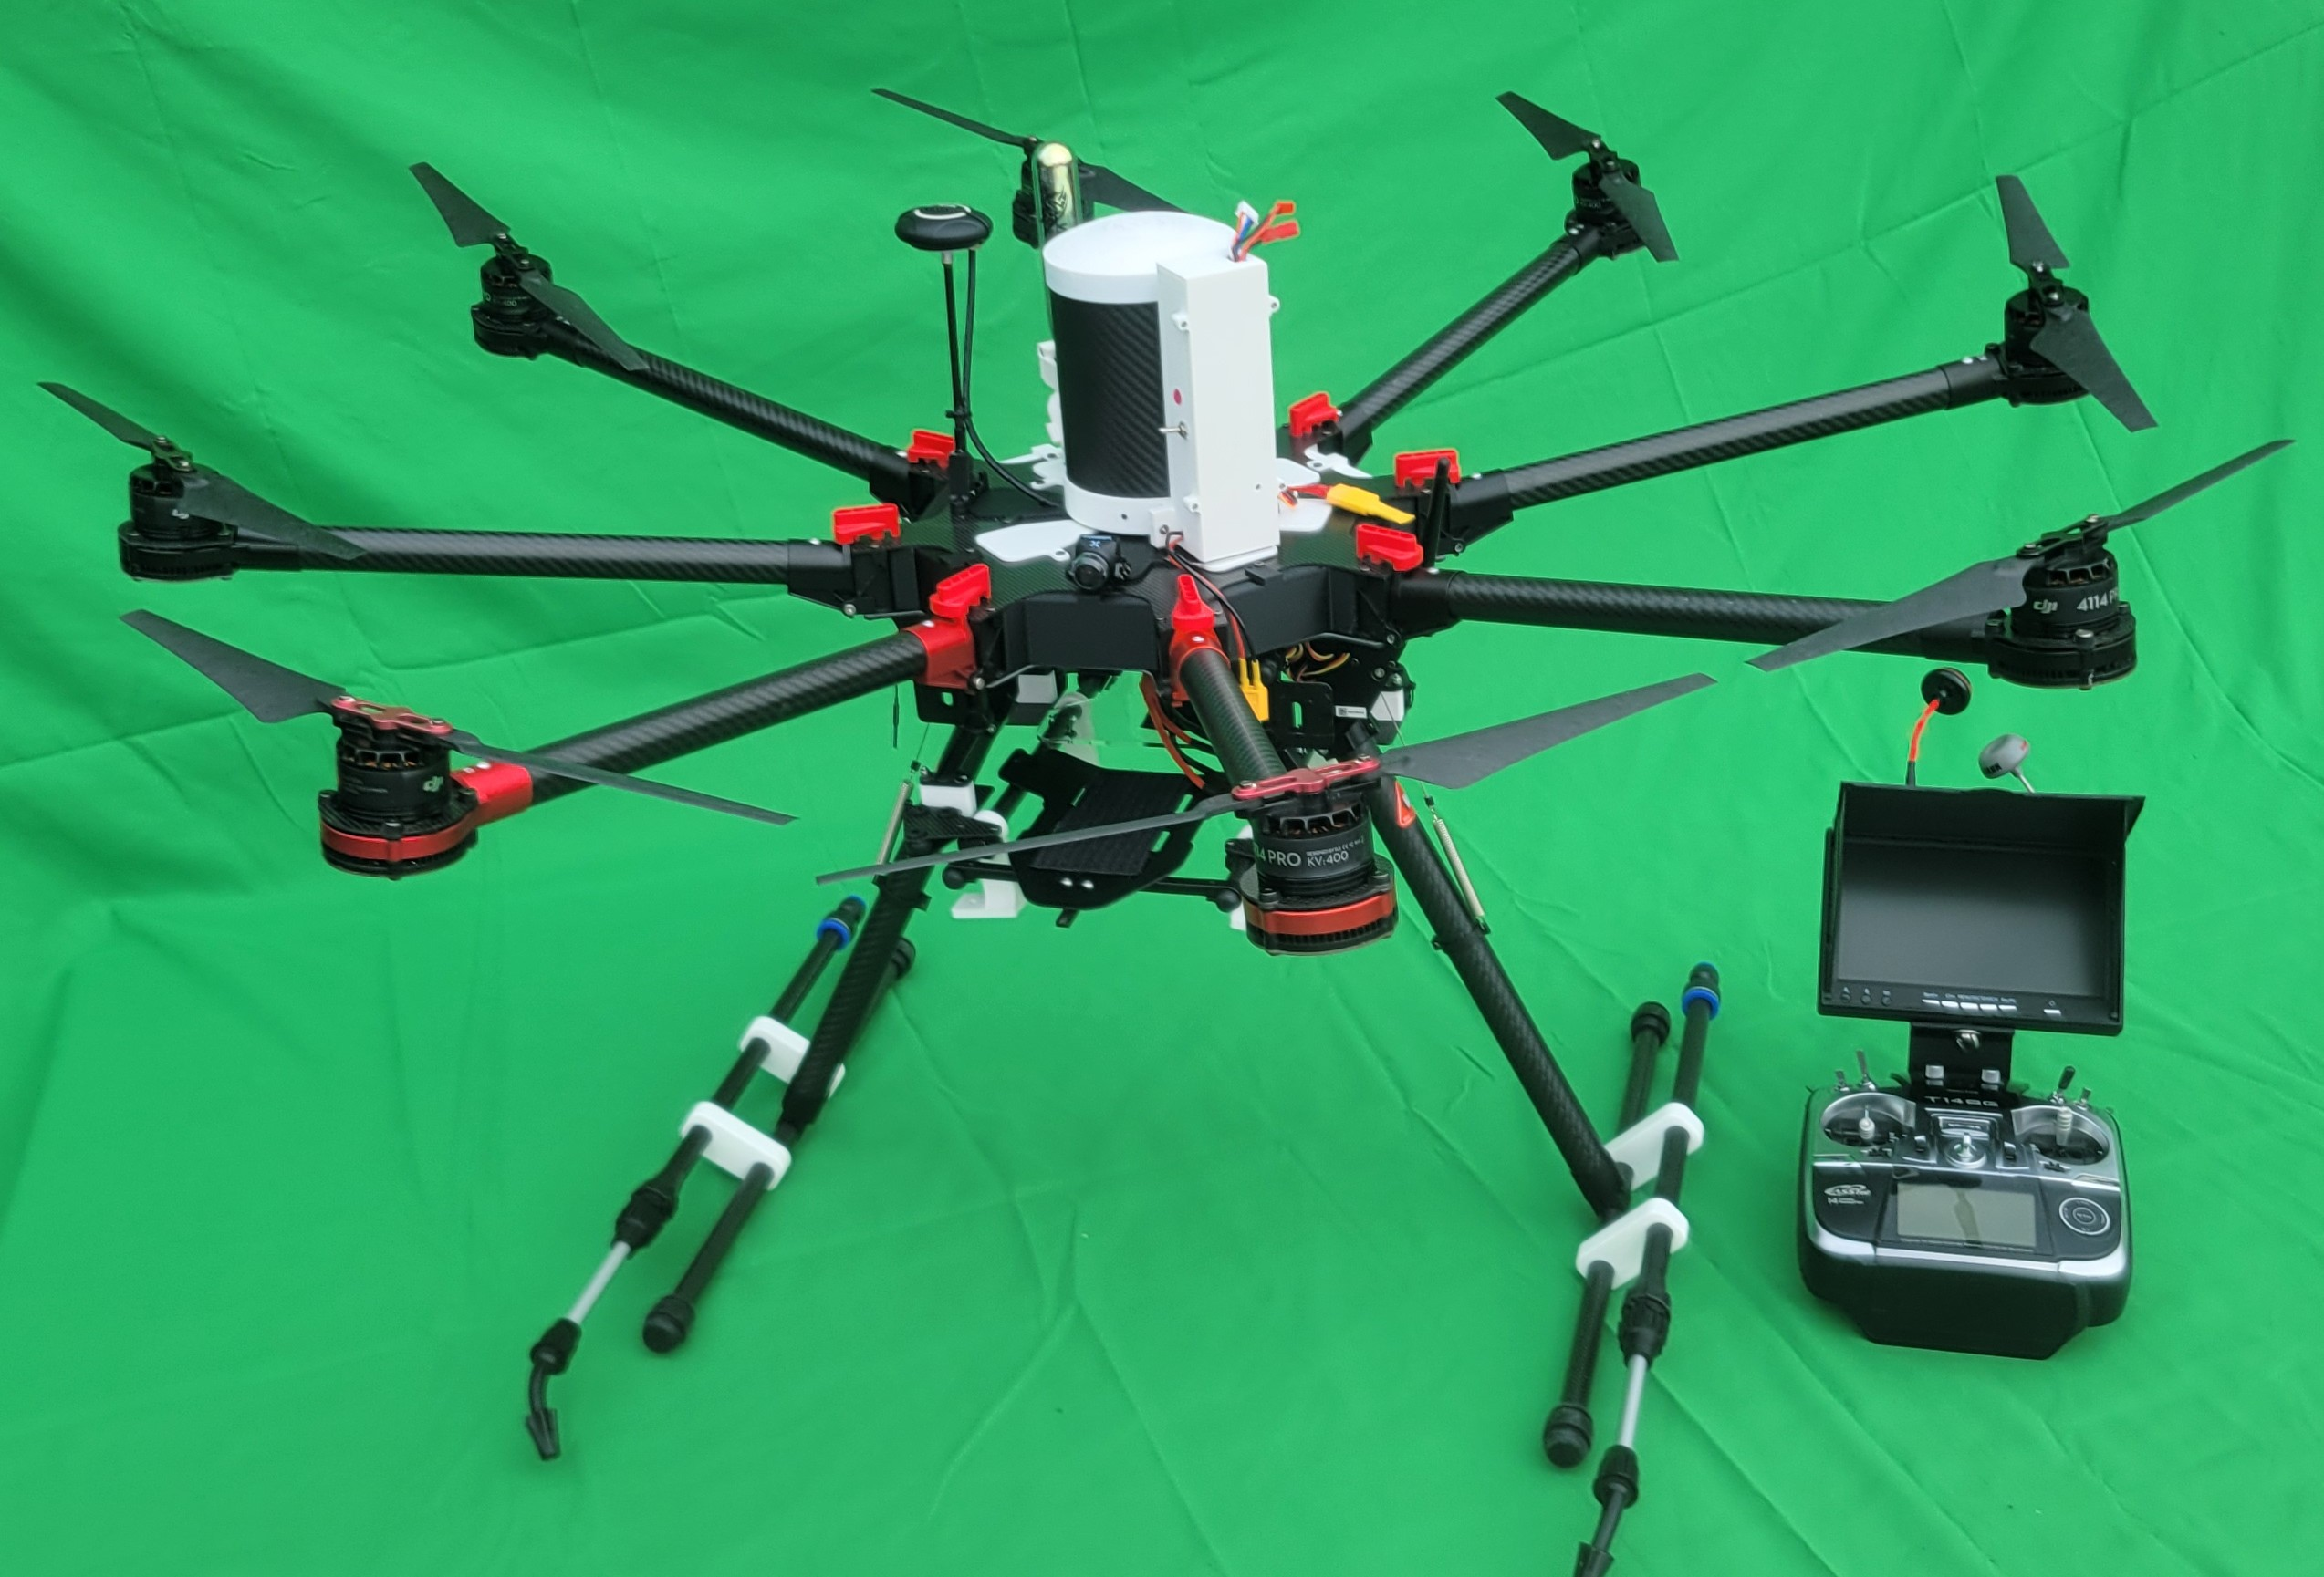

Direct remote identification emission transponder :
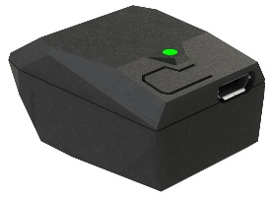

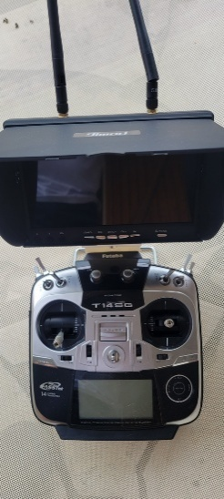
Futaba transmitter T14SG with LCD 7’ HD color

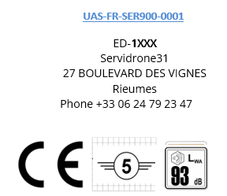
Rieumes, 05/05/2025
UAS-FR-SER1000C5-0001
François HOUSSARD,
